Directions for Using Program Budget Portal Tab to Create an Excel Document
for Application Or A Report to the ARC-PA

Be sure that the Program Budget tab in the portal is up-to-date and complete. New fields were added in July 2024 that need to be completed prior to download. Click “edit” next to each line item to verify that all fields are completed.

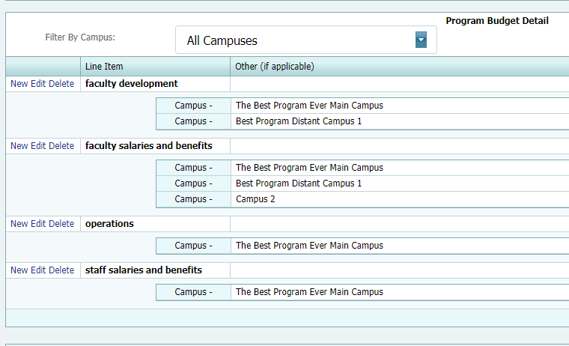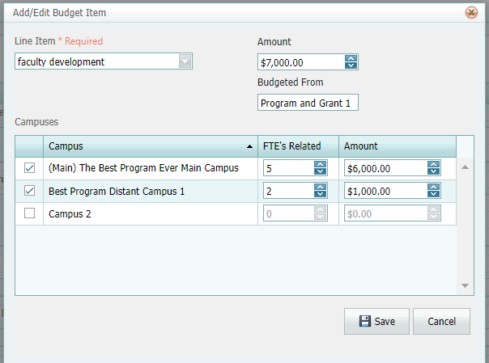

At a minimum, the budget detail in the Budget tab must include the following:
- Program budget for salaries and benefits. List the total amount available, whether funds are budgeted from the PA Program budget, other department (name), dean, provost, institutional budget, grants, etc. (please list all sources for the line item in the budgeted from box):
  - Program faculty salaries and benefits (for the total # positions budgeted which is listed as FTE’s in the box for FTE’s),
  - Staff salaries and benefits (for the total # positions budgeted which is listed as FTE’s in the box for FTE’s),
- Program budget for faculty development (Funding provided to the program director and principal faculty in support of maintenance of certification, licensure, and professional development directly relevant to PA education).
  - List the total amount available, whether funds are budgeted from the PA Program budget, other department (name), dean, provost, institutional budget, grants, etc. (please list all sources for the line item in the budgeted from box).
  - In the FTE’s box on each line, enter the number of FTE’s funded by that dollar amount for each campus.
- Program operations (As indicated in the ARC-PA Program Portal user manual, operations refer to daily operating expenses such as copying, telephone costs, postage, office and lab supplies, books purchased for the program, software, etc. The program budget less salaries and benefits.).
  - List the total amount available, whether funds are budgeted from the PA Program budget, other department (name), dean, provost, institutional budget, grants, etc. (please list all sources for the line item in the budgeted from box).
  - Leave the FTE’s box blank or set to “0” (zero).

When editing the Program Budget tab on the Portal, remember to hit the “Save” button to save changes you have entered. Use one of the two ways listed below to export the budget:

- Click on “Reports” and then “Program Budget Excel Export,” then click on “Export.”

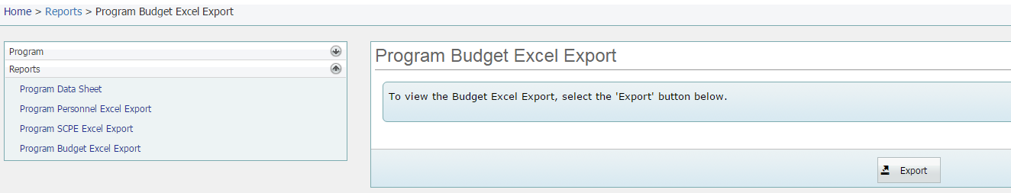

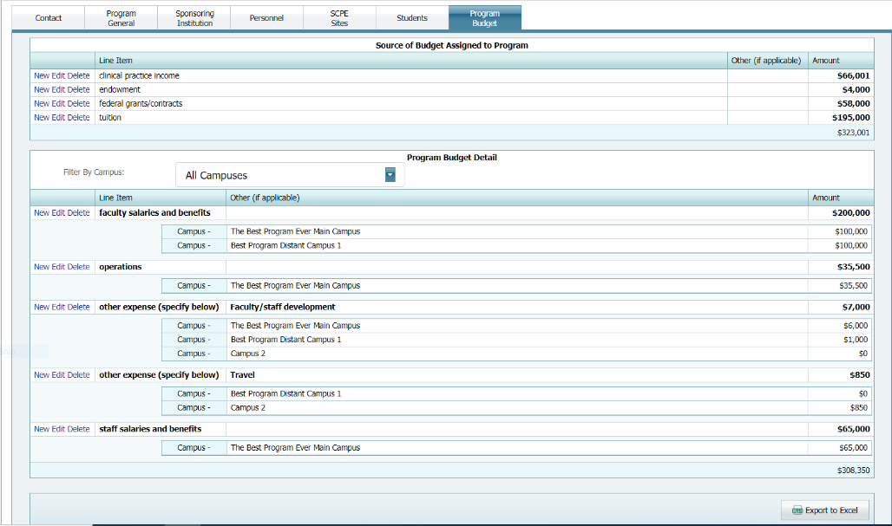
- OR Download the Program Budget tab data to Excel by pressing “Export to Excel” button on the Program Budget tab on the Program Detail page. If you open the page directly you may receive a notice that requires you to “Enable Editing” before you can see the Totals or otherwise use the file.

- Save the downloaded spread sheet as “Program Budget insert program name/abbreviation” Important Note – Abbreviate as necessary; the title should not exceed 30 characters, including spaces. Do not include commas in the document name.

- Keep a copy of the file for your records. Submit the e-copy in the appropriate appendix or as directed in the application, form, or letter from the ARC-PA.

